*A Technical Seminar report on*

Foreign Exchange Currency Rate Prediction using a GRU-LSTM Hybrid Network

*Submitted in partial fulfilment of the requirements for the award of the degree of*

**BACHELOR OF TECHNOLOGY**

**IN**

**INFORMATION TECHNOLOGY**

### Submitted By

### **G. PREETHAM RAO**

**(17071A1279)**

# Table of Contents

**Acknowledgement** 1

**Abstract 2**

**List of Figures**

Proposed Model Flow 9

LSTM Cell state 10

Forget Gate 11

Input Gate 11

New Information vector 11

Output Gate vector 12

LSTM Architecture 12

Hidden state vector 13

Output value 13

GRU cell state 15

GRU Architecture 15

Reset Gate 15

Update gate 16

Candidate Hidden state 16

Hidden state 16

Model Design 18

MSE 20

MAE 20

Distribution curve between actual vs predicted 21

Graph comparing actual vs predicted 22

**List of Tables**

Table comparing performance between standalone and hybrid model 22

**1. Introduction** 3

1.1 OBJECTIVE 5

1.2 MOTIVATION 5

1.2.1 EXISTING METHODS &DISADVANTAGES 6

**2.** **Literature Survey** 7

**3.** **Methodology**

3.1 PROBLEM DEFINITION 9

3.2 PROPOSED SYSTEM 9

3.3 OVERVIEW OF LSTM & GRU

3.3.1 LSTM 10

3.3.2 GRU 14

**4. Implementation**

4.1 DATA COLLECTION 16

4.2 DATA PREPROCESSING 18

4.3 MODEL DESIGN 19

4.4 MODEL VALIDATION 20

**5. Results 21**

5.1 PERFORMANCE EVALUATION 21

5.2 PERFORMANCE COMPARISION 23

**6. Conclusion, Advantages, Future Enhancements**

6.1 CONCLUSION 24

6.2 ADVANTAGES 26

6.3 FUTURE ENHANCEMENTS 26

**7. References** 27

## **ABSTRACT**

The foreign exchange (FOREX) market is one of the biggest financial markets in the world. More than 5.1 trillion dollars are traded each day in the FOREX market. Forex consists of data having particular ordered values in terms of time history. These values have meaning and can be further predicted for the next value. This suggests that deep neural networks, with their ability to learn abstract features from raw data, may provide improved predictive accuracy with raw exchange rates as inputs. It is a very important issue of making decision for foreign exchange player (trader) in foreign exchange market. Accurate prediction of forex will give benefit to forex player. But in reality, it is very hard to predict it due to the high volatility, complexity and fluctuation. Therefore, researchers around the world are continuously coming up with new forecasting models to successfully predict the nature of this unsettled market. For accurate predictions of future closing prices of FOREX currencies, a new model that combines two powerful neural networks used for time series prediction: Gated Recurrent Unit (GRU) and Long Short Term Memory (LSTM) is used. The first layer of our proposed model is the GRU layer with 20 hidden neurons and the second layer is the LSTM layer with 256 hidden neurons. We have applied our model on established currency pair: EUR/USD. The prediction is done for 10 minutes’ timeframe using the data from January 1, 2017 to December 31, 2018 as a proof-of-concept. The performance of the model is validated using MSE, RMSE. Our report also shows the deep learning algorithms, such as gated recurrent unit (GRU) and long short term memory (LSTM), have been fully explored and show huge potential in time series prediction. Moreover, we have compared the performance of our model against a standalone LSTM model, a standalone GRU model and simple moving average (SMA) based statistical model where the proposed hybrid GRU-LSTM model outperforms all models for 10-mins timeframe and provides the best result in terms of MSE, RMSE performance metrics.

# **1.INTRODUCTION**

The foreign exchange market, also known as FOREX, is the world’s biggest currency exchange market with over $5.1 trillion of volume trade per day. It is considered to be very complex and volatile, and is often compared with the black box because of the unknown nature and high fluctuation in currency rates. The foreign exchange (also known as FX or forex) market is a global marketplace for exchanging national currencies. In the FOREX market, currency trading occurs 24 h a day but the trading time is divided into four major time zone. These time zones are the Australian zone, Asian Zone, European Zone, and North American Zone. Each of these zones has its own opening hours and closing hours.

Currencies trade against each other as exchange rate pairs. For example, EUR/USD is a currency pair for trading euro against the US dollar(1 EUR = 1.21 USD). Based on this trade, the foreign exchange market is divided into three different categories: majors, cross-rates, and exotics. Majors are the most traded currencies which are priced against the USD and occupy the majority of the FOREX market. A currency that increases in value against another over many years is generally considered to be a stronger currency. Higher exchange rate is not to be mistaken with strong currency and it does not necessarily represent the status of countries wealth in comparison to other. It is meaningless to look at currency worth at static point, the best way to judge currency strength is by observing values over a significant period.

Each currency pair has its own opening price, highest price, lowest price, and closing price based on the trading session. As the name suggests, **Low is the lowest price** of the day and high price is the highest asset price of the day. The **open**is the price which**the asset started the day** at. Finally, **Close is the final price where the asset trades** at.

For security reasons, it is not possible for one person to directly go to, register with, and buy from the FOREX market. A person needs to use a third party, also known as a broker, for buying currencies from FOREX. Brokers are people or companies that have access to the FOREX market and are able to purchase currencies directly from there. In the FOREX market, a person has only two options available, either buying currencies or selling if they have brought any currencies previously. If the selling rate of the currency is larger than the buying rate, it results in profits for the person. However, like the share market, the FOREX market is also dependent on events that affect the economy of a country. That’s why traders need to know the behavior of the market before they do their trading.

Transactions worth billions of dollars a day take place in the foreign exchange market, making it one of the largest financial markets in the world. Exchange rates are expressed in terms of a base-quote currency pair that represents the number of units of quote currency that may be exchanged for each unit of the base currency. Accurate prediction of forex rate rates is critical for formulating robust monetary policies and developing effective trading and hedging strategies in the foreign exchange market.

Recent years have seen a lot of research interest in the FOREX market currency rate prediction. Many researchers have come up with a lot of unique ideas using machine learning for accomplishing this task. From statistical to deep learning, different models along with hybrid models have arisen on this occasion. Not only are these models diverse but they are also different from each other. It is also quite a tough task to find which model is better among them, but a shortlist can be made by analyzing each of these models.

The recent success of deep neural networks in a variety of domains may be partially attributable to their ability to learn abstract features from raw data. This suggests that deep networks may be effective in predicting foreign exchange rates based on raw time series data. Different implementations of RNN (Recurrent Neural Network) mainly such as LSTM and GRU are being used for time series prediction because of its capability to remember each and every information through time and also for improved prediction ability using the previous inputs of the system. LSTM has proven to be the most accurate and successful algorithm in time series prediction closely following by GRU.

# Objective

The main objective is to demonstrate the combined power of two of the most powerful time-series analyzers: Gated Recurrent Unit (GRU) and Long Short Term Memory (LSTM), to predict FOREX currency price as both are efficient models when used with time-series data as input. For this purpose, we have used a hybrid model that has a GRU at the front layer and LSTM at the back. We applied our proposed model to predict the closing price of four major FOREX currency pairs: EUR/USD. As a proof of our concept, we have predicted the FOREX price for 10 minutes before the actual time. Although many researches have been conducted to predict foreign exchange currency in the past, but still researchers are trying to come up with new models to predict the nature of this market. While there are many machine learning and deep learning approaches used in finance, there is a constant competition where traders look for new techniques to outperform the market. This makes novel approaches more demanding as their uniqueness helps traders to meet their desire in a particular way. Our second objective is to investigate whether deep neural networks are significantly better at foreign exchange rate prediction than time series models and shallow networks when raw exchange rate data are used as input features.

# 1.2 Motivation

Nowadays most of the systems are using different implementations of RNN (Recurrent Neural Network) for time series prediction because of its capability to remember each and every information through time and also for improved prediction ability using the previous inputs of the system. LSTM has proven to be the most accurate and successful algorithm in time series prediction closely following by GRU. GRU is a revised version of LSTM but the working procedure is quite similar. GRU requires less memory as it uses less training parameters thus its faster than LSTM. Though LSTM is a bit of time-consuming, it is more accurate as it uses longer sequences. This gave the motivation to build a hybrid model based on two of the most promising neural networks and to combine the power of these two models into a single one.

# Existing methods & Disadvantages

Along with other fields, predicting the FOREX market has been a key target of investigators over the previous couple of decades. There are two alternative ways to forecast the foreign exchange market: fundamental analysis and technical analysis. Fundamental analysis considers many factors, such as

the economic moat and political state of a country, the reputation of a company, all internal and external trading news, etc. Technical research solely predicts the FOREX market based on a company’s historical data, in particular, the highest price, lowest price, opening price, and closing price of a currency and

the volume traded on a particular day. There’s evidence that people use both of those methods to forecast the exchange rates. The main disadvantages of traditional methods are mixed signals, Analysis paralysis in technical analysis There will be instances when your technical analysis tools will provide mixed or conflicting signals and in fundamental analysis there is lack of market timing, information overload and Intrinsic or Fair Value is based on assumptions. Any changes in the key fundamental factors such as growth can greatly alter the achievable result of the analysis and this led to inclusion of deep learning models such as LSTM and GRU which are used for processing sequential data for future price prediction of foreign exchange currencies.

# **2.LITERATURE SURVEY**

Recent years have seen a lot of machine learning techniques like regression techniques, decision trees, trading rule methods, fuzzy logic, support vector machine, etc. that have been applied for foreign exchange market prediction.  A variety of methods were tested where most of the methods are based on machine learning techniques. Some of these are models include only one processing technique whereas some researchers incorporated a combination of two or more techniques.

Hybrid model based on regression - A hybrid model was developed by Said, Omar, and Aziz who used a combination of regression techniques with the cuckoo search algorithm. Their model was inspired by the autoregressive moving average (ARMA) model and they prepared their dataset with historical data of USD/EUR currency pair. Support vector regression (SVR), multiple linear regression (MLR), CRT regression tree, and partial least squares (PLS) regression methods were used to train their dataset

# Hybrid model based on vector autoregression - Another hybrid model was developed by Paponpat, Kosin and Nattapol for statistic inspection and prediction that’s supported compressed vector autoregression. They used a random compression technique to decrease an outsized number of FOREX data into a reduced form. Then the Bayesian model averaging (BMA) technique was accustomed to the load of every random compressed data to get the intersecting parameters. The currency pairs they used had a high mean squared error due to the predictors used for forecasting were four lagged dependent variables alongside random compression of other forex currency pairs. Their proposed model proved to possess an efficient result for 6 currency pairs: EUR/TRY, CAD/CHF, EUR/DKK, CAD/JPY, EUR/MXN, and AUD/JPY and outperforms the prevailing benchmark of Bayesian Autoregression.

Trading rule based model - Such a rule-based model was proposed by Jia, Yang, Xiao, Changqin, Gansen, and Yong for FOREX online prediction that used the weighted majority (WM) algorithm for selecting experts. So, as a solution, they took online website suggestions into account and predicted according to the suggestions. WM algorithm with adapting empirical risk minimization was used to select a set of suitable experts that have good average profit and less average error. Two sets of experts were evaluated based on the mistake and profit as well as union and intersection. The result analysis showed that the intersection method achieves better accuracy in the 20 days prediction which is 30% higher than the baseline

Another hybrid model was developed by Rajashree who used the mixture of an improved shuffled frog leaping (ISFL) and computationally efficient functional link artificial neural network (CEFLANN) for prediction. The improved shuffled frog leaping was used for reducing the error rate of the system. She used three different currency pairs USD/CAD, USD/CHF, and USD/JPY for her proposed system. to check the performance of the system, two different algorithms Shuffled frog leaping algorithm and Particle Swarm optimization algorithm were used. The result showed that this proposed model performed better than both of the compared algorithms. For RMSE the error rate for USD/CAD and USD/JPY currency pairs was between 0.04–0.05 and for USD/CHF the range was between 0.03–0.04.

Statistical prediction using Support Vector Machine - Thuy and Vuong proposed a model for foreign exchange prediction using SVM. They used the EUR/USD currency pair for their models implementation. They used the cross-validation method for their data-set and divided the results into two categories positive output and negative output. They used accuracy rate, positive, negative, macro averaging, and micro averaging for comparing the performance. Their result showed a big difference (29.5%) between training sets and test sets in the Gaussian RBF method. But only a little difference was found in the polynomial model. According to the result kernel function taken from polynomial provided high performance. They compared the normal transaction method with SVM transactions and found that the profit rate was tripled when using an SVM model.

Dadabada and Vadlamani - provided an overview of the FOREX rates prediction. They studied and reviewed 82 hybrid systems that were used for currency exchange rate prediction in the duration of 1998 to 2017. They noticed that artificial neural network-based hybrid systems provided more stability and accuracy in predicting the rates. The analysis showed that hybrid models performed better than stand-alone model.

# **3.METHODOLOGY**

# 3.1 Problem Definition

Predicting multi-currency exchange rates and processing time series information using different hybrid deep learning models like Long Short-Term Memory (LSTM) and Gated Recurrent Unit(GRU). Comparing the performance between the standalone models and the hybrid model(LSTM-GRU).

# 3.2 Proposed System

The prediction process starts from acquiring the datasets for EUR/USD currency pair. Then training the system, predicting rates and then acquire the performance of the model using MAE, MSE. This proposed model of forecasting foreign exchange rates uses deep learning algorithms like LSTM and GRU.  Lastly, we validate the performance of our model for the currency pair EUR/USD. We have applied our model to predict the closing price of each currency pair before 10 minutes than the actual time.

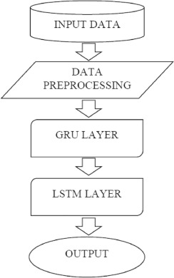

# 3.3 OVERVIEW OF LSTM AND GRU ALGORITHMS

# 3.3.1 LSTM

Long Short-Term Memory (LSTM) networks are advanced recurrent neural networks that are capable of learning order dependence in sequenced information problems.

LSTM is capable of remembering information for a long period of time using a memory unit. LSTM deals with the main drawback of RNN which is vanishing/exploding gradient problem and the shortcoming is, they cannot remember Long term dependencies due to vanishing gradient. LSTMs are explicitly designed to avoid long-term dependency problems.

**CELL STATE:**

At a high-level LSTM works very much like an RNN cell. Here is the internal functioning of the LSTM network. There are three parts of LSTM cell known as controllers, more often called gates. They are input gate, output gate and forget gate and these gates control the stream of data inside the LSTM unit.

The first part chooses whether the information coming from the previous timestamp is to be remembered or is irrelevant and can be forgotten. In the second part, the cell tries to learn new information from the input to this cell. At last, in the third part, the cell passes the updated information from the current timestamp to the next timestamp.

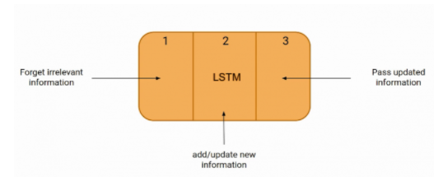

σg: sigmoid function

σh: hyperbolic tangent function

W, U, b: weight matrices and bias vector parameters.

xt: input vector

Just like a simple RNN, an LSTM also has a hidden state where H(t-1) represents the hidden state of the previous timestamp and H(t) is the hidden state of the current timestamp. In addition to that LSTM also have a cell state represented by C(t-1) and C(t) for previous and current timestamp respectively. Here the hidden state is known as Short term memory and the cell state is known as Long term memory.

FORGET GATE:

In a cell of the LSTM network, the forget gate determines whether we should keep the information from the previous timestamp or forget it and this the first step.



Later the sigmoid function is applied over it and the ft is bounded between 0 and 1. If ft =0 then forget everything or ft=1 include/remember everything from previous timestamp.

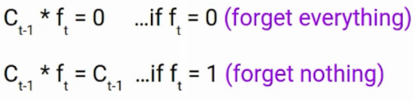

INPUT GATE: Input gate is used to quantify the importance of the new information carried by the input. Here is the equation of the input gate.



The objective of this gate is to protect the information of the cell state, which has accumulated over previous time steps, from irrelevant updates. Therefore, the input gate selectively updates the cell state with new information. Now the new information that needed to be passed to the cell state is a function of a hidden state at the previous timestamp t-1 and input x at timestamp t. The activation function here is tanh.



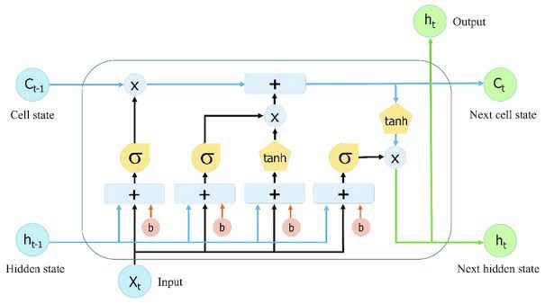

OUTPUT GATE: The final step is to decide what will be the output of the system. The output is based on the cell state but a filtered version of it. A hyperbolic tangent is applied to the values of the current cell state to produce a version of the cell state that is scaled to the interval [−1,1].



The output gate ot consists of a sigmoid with arguments ht−1 and xt, and determines which information to pass on to the output layer and subsequent time steps in the new hidden state ht. The hidden state is calculated using the equation:



It turns out that the hidden state is a function of Long term memory (Ct) and the current output. If you need to take the output of the current timestamp just apply the SoftMax activation on hidden state Ht.



# 3.3.2 GRU

GRU or Gated recurrent unit is an advancement of the standard RNN i.e. recurrent neural network. A second approach to overcome the vanishing gradient problem which occurs in a standard recurrent neural networks is GRUs.

GRUs are very similar to Long Short Term Memory(LSTM). Just like LSTM, GRU uses gates to control the flow of information. They are relatively new as compared to LSTM. This is the reason they offer some improvement over LSTM and have simpler architecture. Another Interesting thing about GRU is that, unlike LSTM, it does not have a separate cell state (Ct). It only has a hidden state (Ht).

CELL STATE:

The GRU cell is more or less similar to an LSTM cell or RNN cell. At each timestamp t, it takes an input Xt and the hidden state Ht-1 from the previous timestamp t-1. Later it outputs a new hidden state Ht which again passed to the next timestamp.

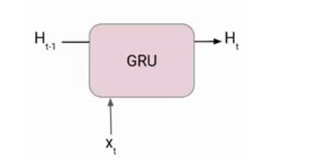

Now there are primarily two gates in a GRU as opposed to three gates in an LSTM cell. The first gate is the Reset gate and the other one is the update gate. The update gate in GRU couples the tasks of LSTM’s forget and input gates.

RESET GATE: Reset gate helps the model to determine how much of the past information needs to be forgotten. It is responsible for the short-term memory of the network i.e. the hidden state (Ht). Here is the equation of the Reset gate.



UPDATE GATE: we have an Update gate for long-term memory to determine what previous information is to be kept and the equation of the gate is



To find the Hidden state Ht in GRU, it follows a two-step process. The first step is to generate what is known as the candidate hidden state.



If the value of rt is equal to 1 then it means the entire information from the previous hidden state Ht-1 is being considered. Likewise, if the value of rt is 0 then that means the information from the previous hidden state is completely ignored.

Once we have the candidate state, it is used to generate the current hidden state Ht. It is where the Update gate comes and instead of using a separate gate like in LSTM in GRU we use a single update gate to control both the historical information which is Ht-1 as well as the new information which comes from the candidate state.



The value of ut is very critical in this equation and it can range from 0 to 1.

# **4.IMPLEMENTATION**

# 4.1 Data Collection

The dataset was collected for major currency pair EUR/USD. We have collected two years of historical time series data from 1st January, 2017 to 31st December, 2018 for our 10 minutes prediction model. For developed currency markets, we use the daily OHLC rates between the currency pair: Euro and US Dollar (EUR/USD) to train and test our models. Each dataset contains a total of 5 attributes: *Date and Time, Open price, High price, Low price*, and *Close price*. These datasets contain OHLC (Open-High-Low-Close) time-series data for a 1-minute interval of the entire 24 hours each day. This collected data is used as input data which is fed to the hybrid model after preprocessing.

# 4.2 Data Preprocessing

Pre-processing done by handling missing data with the interpolate method and data are scaled but each of the collected datasets didn’t have any missing values, therefore we didn’t have to deal with that. Features transformed by mounting every element to a given range. Scales and interprets each component independently, it is in the given field on the training dataset. However, the dataset contained the 1 minute interval data values and was huge in size as well. We converted these 1 minute OHLC datasets into 10-mins datasets where we have calculated and combined the data values in the following manner.

Date and Time: 10 minutes time interval between each instance of the data

Open price: The open price of the first minute of the 10 minutes time interval when the calculation starts for 10 minutes dataset.

High price: The highest price value that is reached between these 10 minutes for respective datasets.

Low price: The lowest price value that is reached between these 10 minutes for respective datasets.

Close price: The close price of the last minute of the 10 minutes time interval when the calculation ends for 10 minutes datasets respectively

For getting a better relation between the data and for getting a better training result, we have added some additional attributes to our datasets. These attributes are: Hour, Day, Week, Momentum, Average price, Range, and OHLC price. The attributes are calculated from the original dataset as follows.

Momentum = Open price – Close price

Average price = (Low price + High price) / 2

Range = High price – Low price

OHLC price = (Open price + High price + Low price + Close price) / 4

# 4.3 Model Design

The proposed hybrid model is built using four layers, where the first layer contains GRU with 20 hidden neurons and the second layer contains LSTM with 256 hidden neurons. The third layer and fourth layers are dense layers with 64 and 1 hidden neurons respectively. We have trained this model using the 10 minutes interval data which we have processed from the original 1-minute interval data. The percentage of training data and testing data are 80% and 20% respectively. In numbers, training data is approximately slightly larger than 60000 on average for 10 minutes prediction model while testing data is approximately slightly larger than 14000 on average for 10 minutes prediction model for currency pairs.

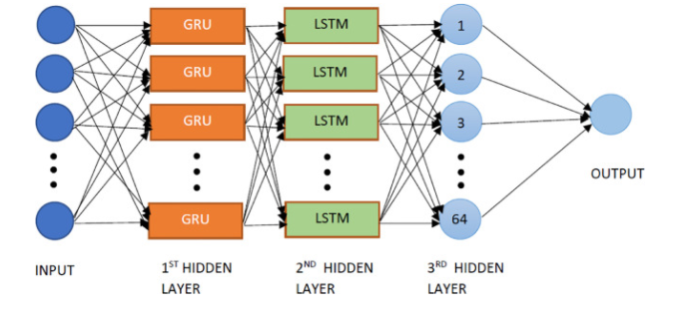

GRU LAYER: First, all the attributes of the dataset are used as the input of the GRU layer. GRU is our first hidden layer. Each GRU neurons collect the data and along the path, a weighted value is generated.

LSTM LAYER: Data is then passed from the GRU layer to the LSTM layer which is our second hidden layer. Again a weighted value is generated along the path from the GRU layer to the LSTM layer.

DENSE LAYER: Similarly, data is then passed to the Dense layer which is the third hidden layer. A weighted value is generated from LSTM to Dense layer. The dense layer is a normal neural network layer that we have used to produce the output. From the third hidden layer, the data is then passed to the output neuron and weight is generated correspondingly. The output is then compared with the original value to find out the error function.

The weighted values are then updated according to the difference of the actual value and predicted value until it reaches the minimum point of the cost function and weights are then saved for future predictions. Based on the saved weighted values, the future predictions for 10 minutes are done and the system’s performance is measured.

# 4.4 Model Validation

A loss function is the main constraint required to validate a model. Loss function calculates how well the model works by comparing the values between calculated value and real value. It is also known as Error Function.

Validation is an important step that is used to check the performance of the system by comparing the actual data with predicted data. Here we have used MSE (Mean Squared Error), RMSE (Root Mean Square Error), MAE (Mean Absolute Error) for measuring the performance of our system. Among them in MSE and RMSE, the error of each data point is squared before taking the average. This implies that these two metrics puts more weight on the larger error. MSE and RMSE can be very useful when a large error is very much undesirable which is true for FOREX prediction as well. On the other hand, MAE takes the average of absolute error of all data points. MAE is not too sensible to outliers comparing to MSE or RMSE. But it useful when the performance is measured on continuous data which is also true in our case. The smaller the values these matrices have, the better is the model.

MSE: Mean Square Error (MSE) is the most commonly used regression loss function. It is the sum of squared distances between our target variable and predicted values.

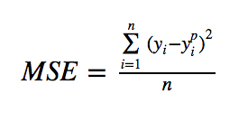

MAE: Mean Absolute Error (MAE) is another loss function used for regression models. MAE is the sum of absolute differences between our target and predicted variables.

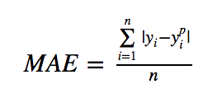

RMSE: Root Mean Square Error is calculated from square root of MSE.

# **5. RESULTS**

The results of the prediction model for FOREX Currency Rates based on hybrid RNNs can be evaluated through performance evaluation by comparing the actual and predicted values. After training system repeatedly, the following parameters set for the best results. We have applied our model to predict the closing price of each currency pair before 10 minutes and 30 minutes than the actual time. Also, we have compared our proposed models against a standalone GRU, a standalone LSTM, and a statistical model that is based on the moving average technique.

# 5.1 PERFORMANCE EVALUATION

For each currency pair, our model was trained using the 20-256-64 formation of the hidden layers and was run for 100 times. The prediction was then done on the 20% of the total data. Then the performance was measured using the performance matrices MSE, RMSE and MAE which compares the difference between actual and predicted values and provided a result between 0 and 1. We chose the performance matrices MSE, RMSE, and MAE to check the error rate our model provides as the quality of any regression model can be understood by its error rate.

For the EUR/USD currency pair, we validated the model against 14886 samples for our 10-mins model and 3723 samples for our 30-mins model that is 20% of our total data respectively. The model is trained using the rest of the data.

The graph presents the distribution of differences between actual and predicted curve. The x-axis represents the difference between the actual and predicted value and the y-axis represents the frequency of scores for each value.

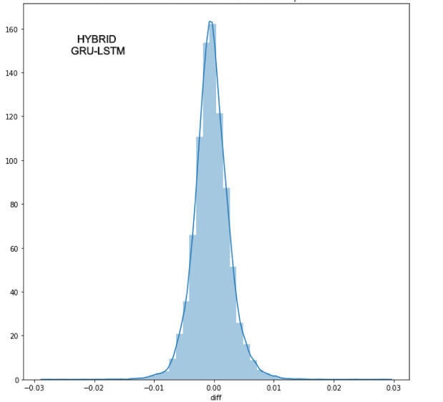

The graph shows the actual value vs predicted value curve for EUR/USD pair for 10-mins timeframe. Here, the x-axis indicates the number of samples we have used for validation, which in this case is 14886 for 10-mins. The actual closing values of the currency pair are marked by a yellow color, and the model predicted closing values are marked by blue color. The y-axis indicates the unit value of this pair which in this case is the normalized closing price of EUR/USD currency pair. The fluctuation in the curve indicates the ups and downs of the closing prices.

The graphs clearly show how accurate the predictions are: actual and predicted values almost overlap with each other.

EUR/USD currency pair in 10-min timeframe

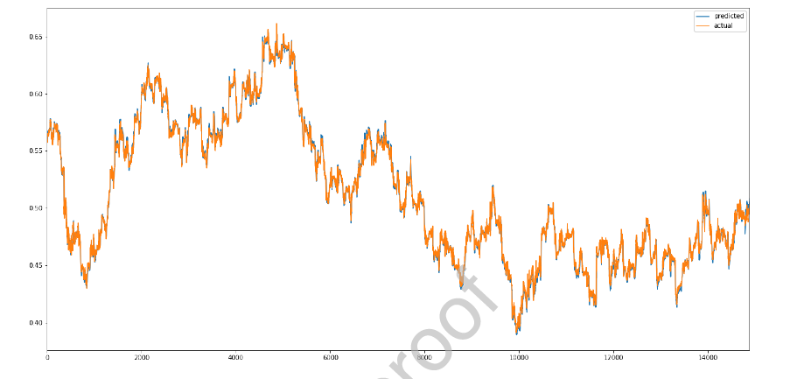

# 5.2 Performance Comparison

To determine how good a model is, we have compared our hybrid GRU-LSTM model against a standalone GRU model, a standalone LSTM model, and a simple statistical model where we have used simple moving average (SMA) of previous 20-days closing price. Moving average is used for filtering out the noise and smoothing the price trend. We have considered a 20-days moving average for analyzing the performance as a 20-days moving average is proven to provide the best result.

To show the comparison for 10-mins timeframe in terms of MSE, RMSE and MAE values for currency pair. For any currency pair, our proposed model outperforms the other models.

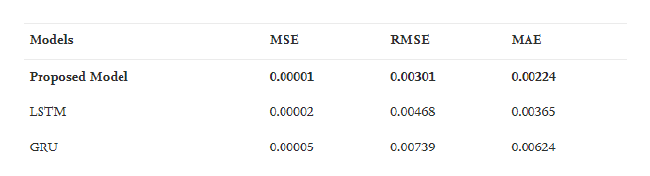

**6. CONCLUSION, ADVANTAGES AND FUTURE ENHANCEMENTS.**

# 6.1 Conclusion

Forecasting of the future currency prices in Foreign exchange market using hybrid model combining GRU and LSTM as experimental results show that the GRU-LSTM hybrid model predicted prices are more accurate than two of the most popular and reliable stand-alone time series analyzers: LSTM and GRU. We have predicted the price of 10 minutes before the actual time as a proof-of-concept. We have collected a 1-minute interval dataset from the histdata and converted them into 10 minutes. Then we have inserted the data into a GRU model where it generates a weighted value and then passes the data to the LSTM network. LSTM calculates another weight value and passes the data to the dense layer. Dense layer produces the overall model output and then passes the result to the output layer. In the output layer, the system generated output is compared against the actual output and weighted values are optimized so that the value of the loss function minimizes. In the output layer, the system generated output is compared against the actual output and weighted values are optimized so that the value of the loss function minimizes. We have also compared our proposed hybrid model against a simple statistical model that uses the simple moving average of the previous 20-days closing price. In terms of risk associated with the return, the proposed model maintains its superiority among all the models for any timeframe. This demonstrates the appropriateness of the Deep learning using LSTM, GRU-Neural Networks to the issue of multi-currency exchange rate prediction. The outcomes are profoundly promising; results showed that the average accuracy of the predicting model exceeds 99 %.

# Advantages

As the quick improvement of economy and innovation, money markets have turned into a vital piece of our day by day life, and because of its high fluctuation a prediction with high accuracy is given by this hybrid model.

* It aids the traders in faster decision making. The deep learning techniques which are possible to automate for trading strategies make it easy to respond quickly to market fluctuations with monitoring and analyzing data.
* Higher profits results to high economy as the focal point is pattern foreseeing and our model is built to do this. The most common benefits it is known for are cutting the high costs and saving time for the people in the field to focus on creativities and tasks that are not that routine and time-consuming.
* Lower risks as the values are pre predicted and mostly ground truth does not alter much from the predicted value.

# 6.3 Future Enhancements

* One of future enhancement could be addressing the limitation of low confidence predictions by using scaled prices as inputs, either with the same targets as in this experiment or to predict price levels in a regression and then transform the outputs to binary predictions by comparing them to the previous day’s price.
* Another avenue for future research concerns the employed trading strategy. Employing a more advanced trading rule might help to overcome the discrepancy between statistical and economic results.

# **7. REFERENCES**

[1] Md. Saiful Islam, Emam Hossain

Journal -Foreign Exchange Currency Rate Prediction using a GRU-LSTM Hybrid Network <https://www.researchgate.net/publication/345992198_Foreign_Exchange_Currency_Rate_Prediction_using_a_GRU-LSTM_Hybrid_Network>

[2] Amit R Nagpur

Prediction of Multi-Currency Exchange Rates Using Deep Learning- International Journal of Innovative Technology and Exploring Engineering (IJITEE)

https://www.ijitee.org/wp-content/uploads/papers/v8i6/F3578048619.pdf

[3] Md. Saiful Islam, Emam Hossain , Abdur Rahman, Mohammad Shahadat Hossain and Karl Andersson

A Review on Recent Advancements in FOREX Currency Prediction

https://www.researchgate.net/publication/343342034_A_Review_on_Recent_Advancements_in_FOREX_Currency_Prediction

[4] Alexander Jakob Dautel, Wolfgang Karl Härdle, Stefan Lessmann & Hsin-Vonn Seow

Forex exchange rate forecasting using deep recurrent neural networks

<https://link.springer.com/article/10.1007/s42521-020-00019-x#Sec29>

[5] <https://www.analyticsvidhya.com/blog/2021/03/introduction-to-long-short-term-memory-lstm/> for LSTM